**PRACTICAL NO: 03**

**Aim: Perform the steps to perform the Customization on WordPress.**

Step1: Login as Admin at WordPress.

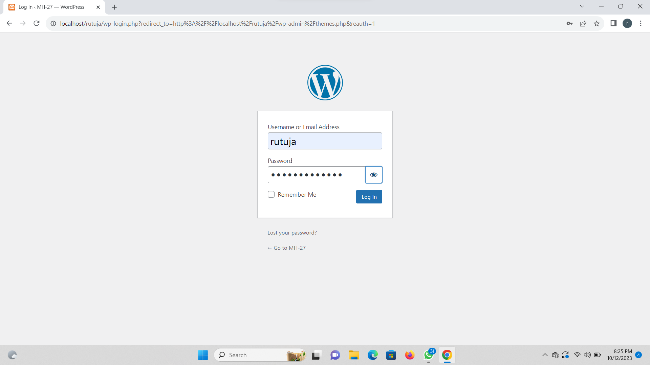

Step 2: Click on Appearance and click on customization.

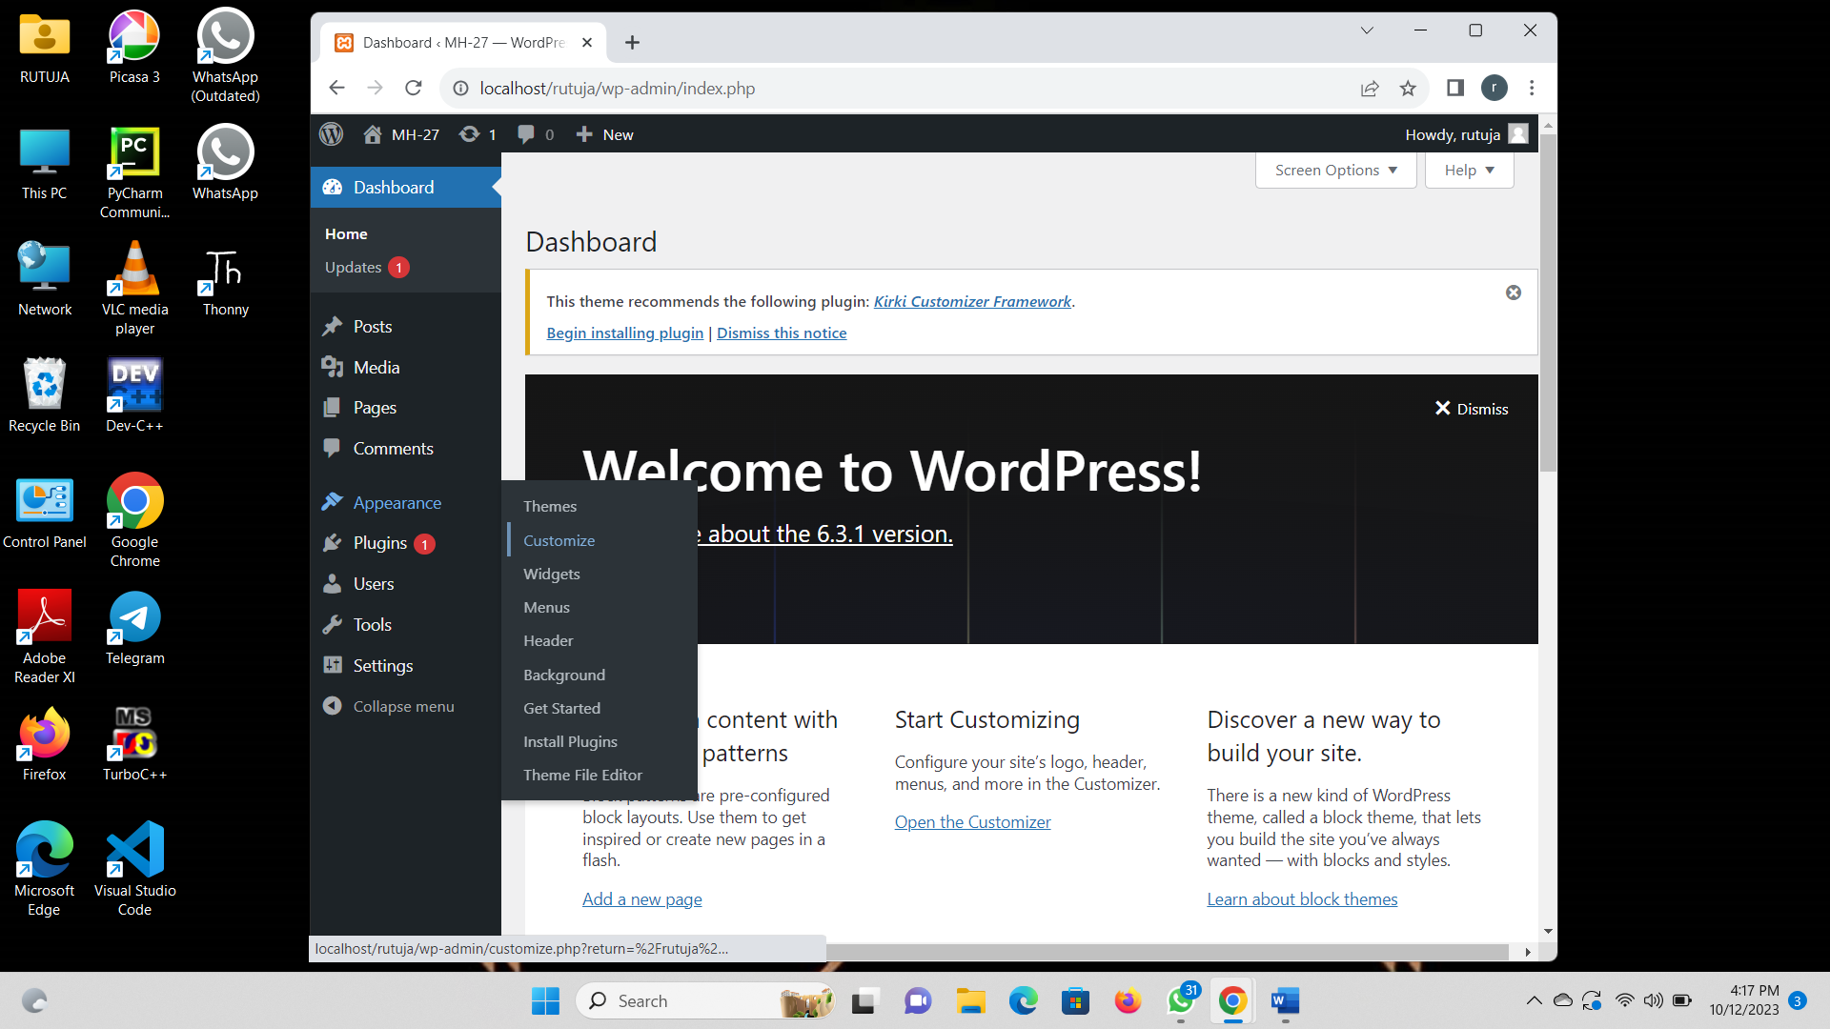

Step 3: Click on site identity and select the logo for your site.

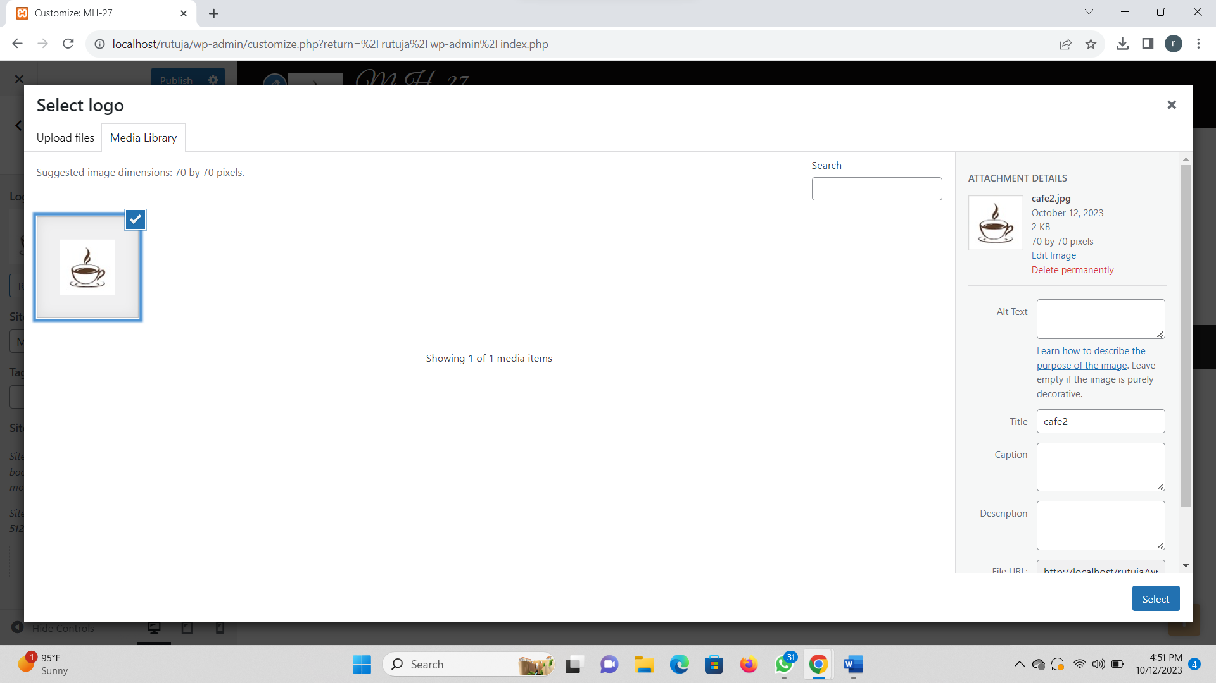

Step 4: Select the logo for your site and also the site title and tag list.

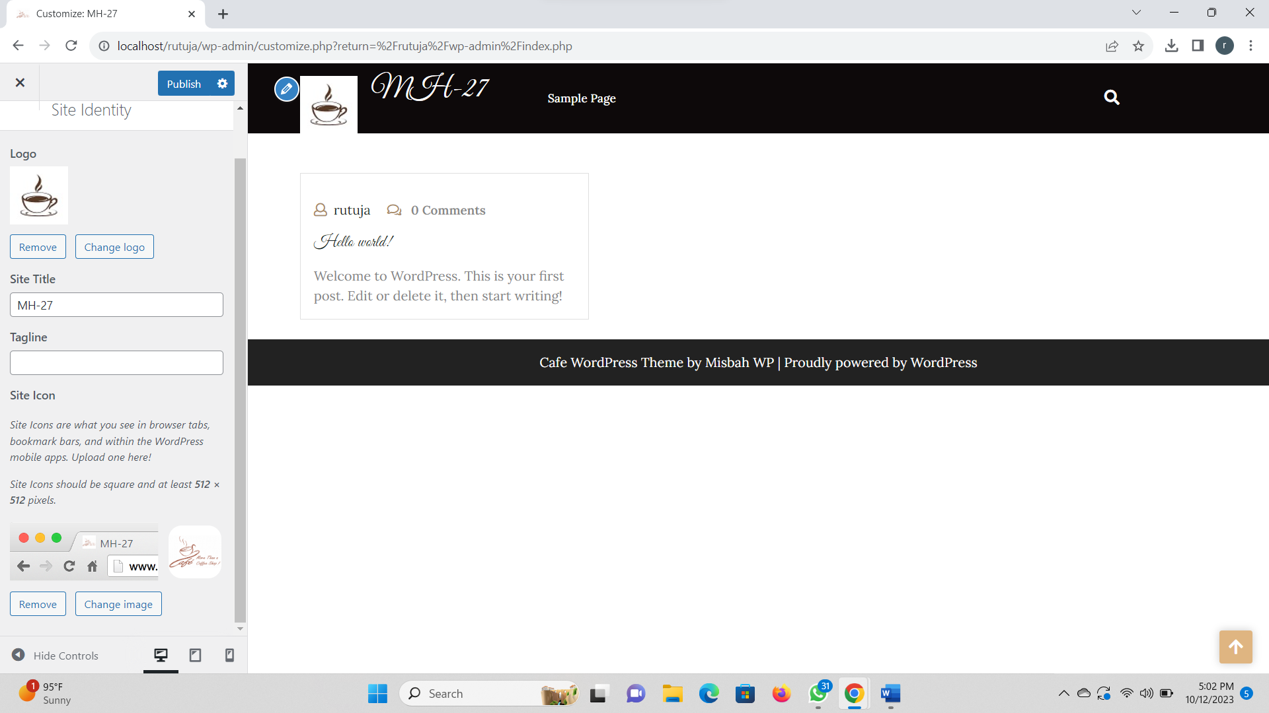

Step 5: Now setting of the Homepage setting like below.

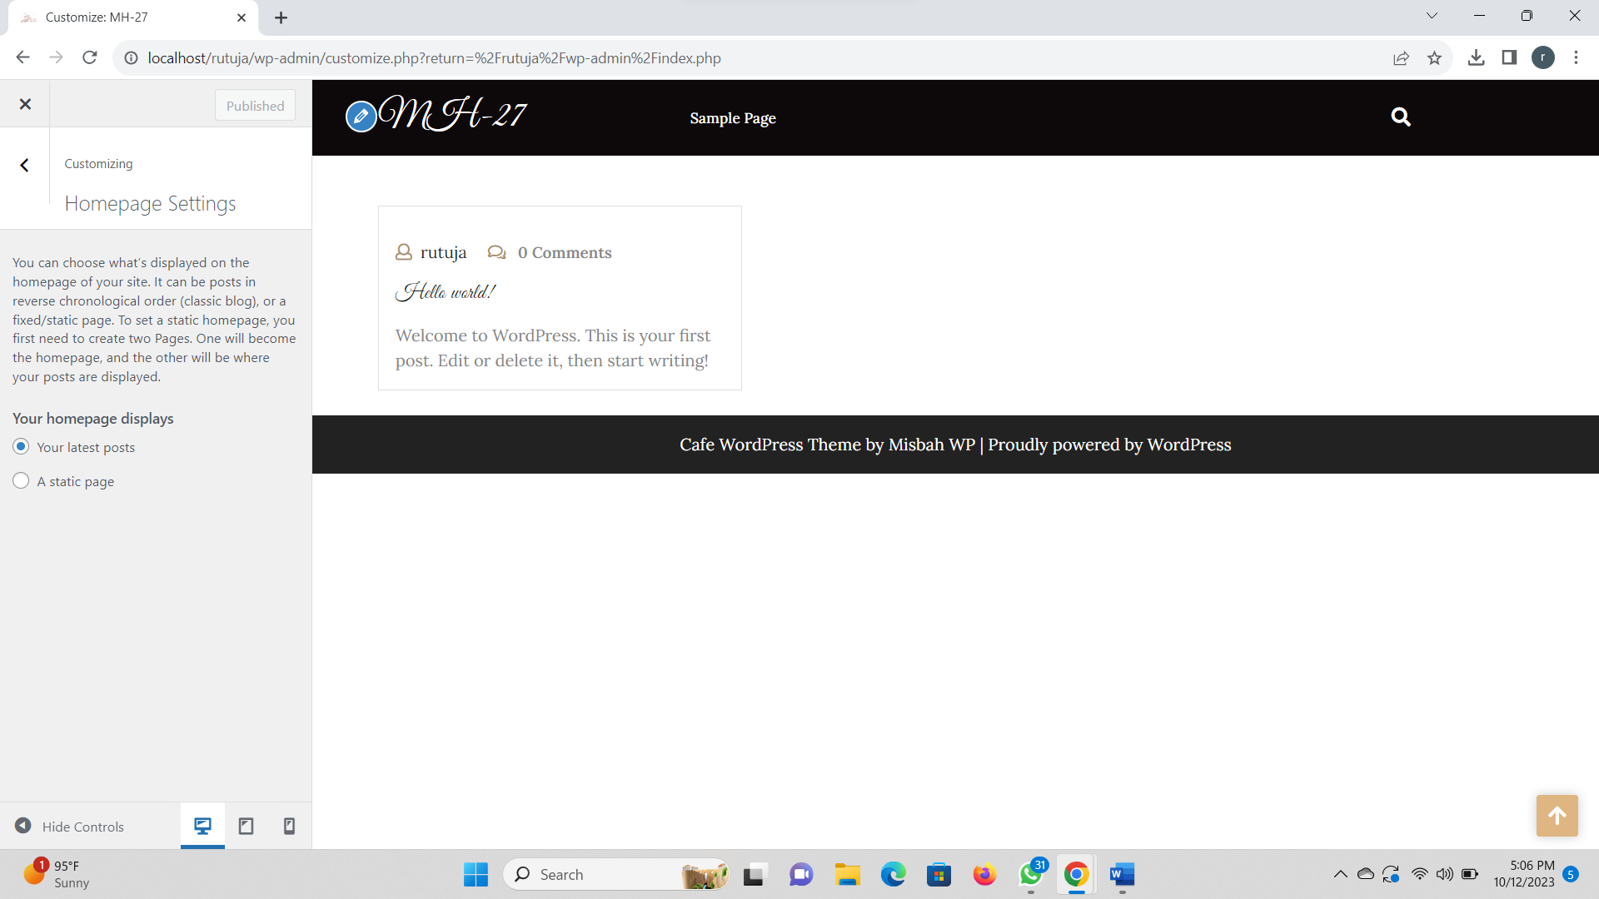

Step 6: Add the additional CSS files.

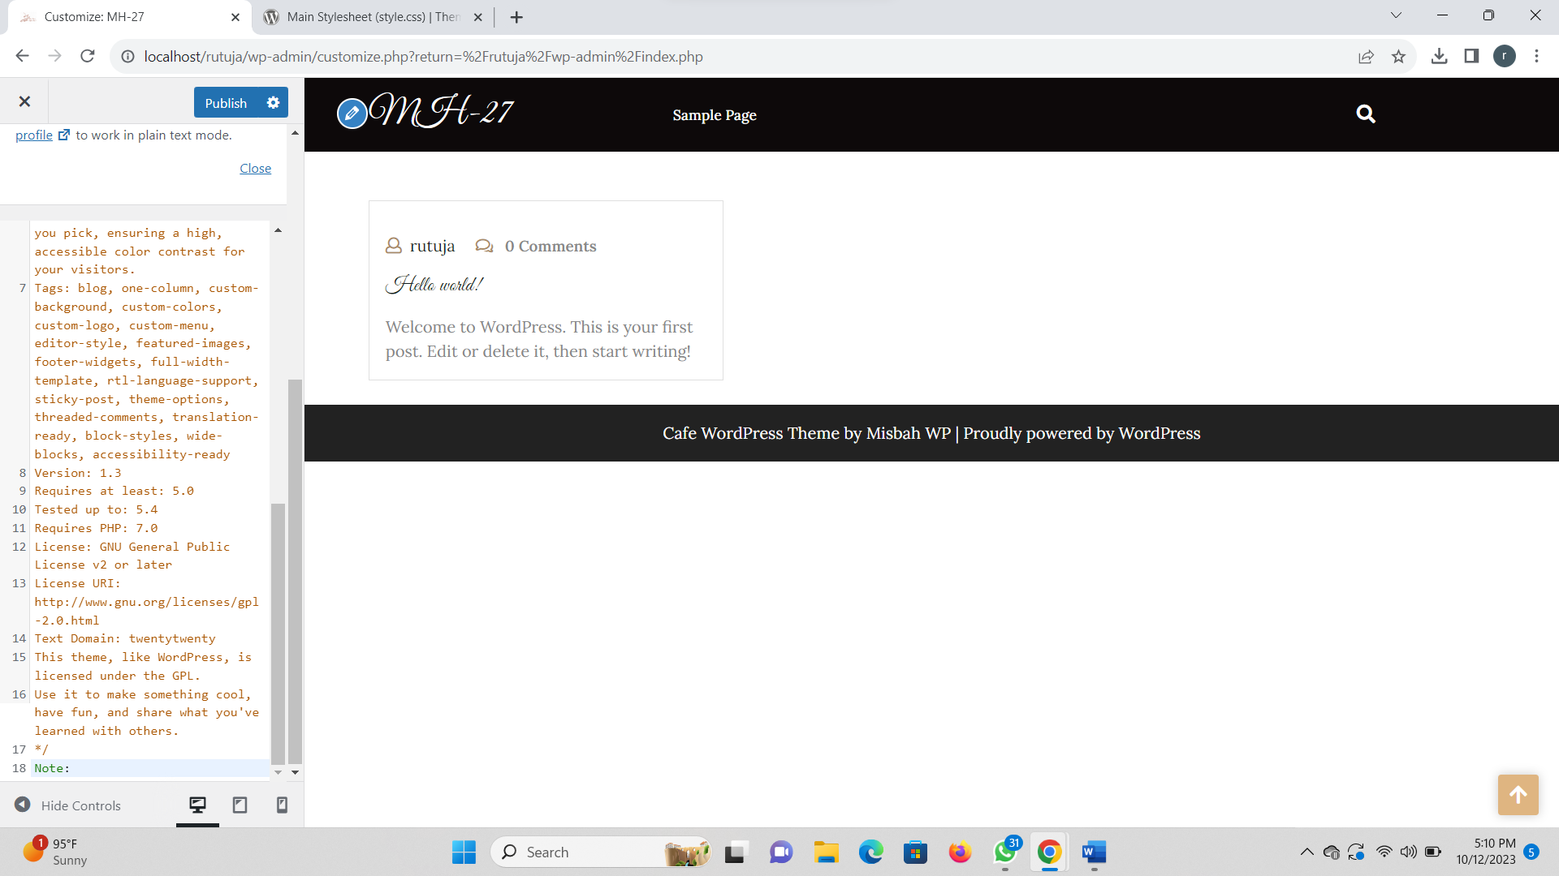

Step 7: Frontend.

